SQL Code Documentation

Table of Contents

Introduction

Database Schema

Stored Procedures

Views

Triggers

Indexes

Constraints

Maintenance

**1. Introduction Ltreem data warehouse.**

This document provides an overview and documentation for the SQL code used in the Clients_PlayGround.Letreem data warehouse It aims to help developers and database administrators understand the database schema, stored procedures, views, triggers, indexes, and constraints implemented in the database.

**2. Database Schema Clients_PlayGround.**

The database schema defines the structure of the database, including tables, columns, relationships, and constraints.

2.1. Tables

Based on the project that I developed, the database has various Dimension table and one fact

Table.

The Table used on the database are as follows

* Store_dim_tbl
* manager_dim_tbl
* Supervisor_dim_tbl
* promotion_dim_tbl
* product_dim_tbl
* order_dim_tbl
* Date_dim_tbl
* customer_dim_tbl
* sales_facts_tbl

2.2. Relationships

In our relationship, facts and dimension table are related based on identity relationship. The primary keys in our dim table are mostly foreign key In our facts table.

Below is a snapshot of the fact tables and dim foreign keys related to it.

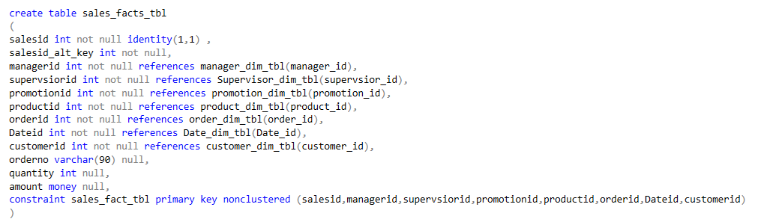

3. Stored Procedures <a name="stored-procedures"></a>

The stored procedure for loading data from our xml is still in production once its done it will be attached on the git.

Below is our Table with its keys and how we connect to the source and vice verse

|  |  |  |  |
| --- | --- | --- | --- |
| Source tables | Columns | Dimesion tables | columns |
| Storetbl | storeId | Store_dim_tbl |  |
| managertbl | ManagerId | manager_dim_tbl |  |
| Supervisortbl | SupervisorId | Supervisor_dim_tbl |  |
| promotiontbl | promtionid | promotion_dim_tbl |  |
| producttbl | productid | product_dim_tbl |  |
| ordertbl | orderid | order_dim_tbl |  |
| Datetbl | dateid | Date_dim_tbl |  |